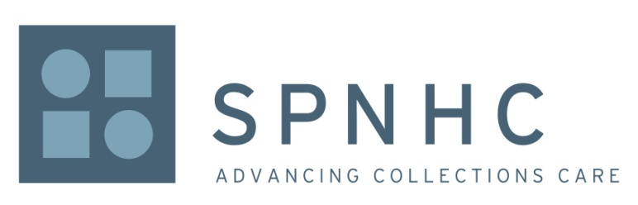

Application for Christine Allen Travel Grant 2024

Application Deadline: May 31, 2024, Close of Business (COB) Your Local Time

The Society for the Preservation of Natural History Collections (SPNHC) is offering travel grants for the 2024 SPNHC Annual Meeting, https://spnhc.org/events/event/spnhc-tdwg-2024/. Applicants must be members of the Society or apply for membership before the application will be accepted. While any SPNHC member may apply, preference will be given to students (undergraduate or graduate) and emerging professionals, focused on the physical care, management, or preservation of natural history collections.

A letter of support from the applicant's advisor, supervisor, or professional mentor should be submitted, together with this application. (See below for instructions for submission.)

SPNHC members from the following countries are strongly encouraged to apply—Central and South America, Africa, Asia, and Eastern Europe.

Name
Institution
Address
City
State/Province
Zip Code
Country
Country of Residence
Email address(es)
Are you presenting a paper? |  | Y | N
Are you presenting a poster? |  | Y | N
Are you a current member of SPNHC? If yes, put the number of months or years you have been a member in the box with the “Y.” |  | Y | N
Are you receiving any additional funds to attend this meeting? |  | Y | N

Respond to each of the following five questions, limiting your response to 400 words total per question.

1. Give a brief description of your institution. (Students - Describe your course of studies.)
2. Give a brief description of your current position, duties, and number of years in the profession. (Students - State your goals in the profession.)
3. How will your attendance at the SPNHC annual meeting strengthen your career as well as your work at your institution? (Students - How will your attendance strengthen your future career? How will it help you meet your goals in the profession?)
4. I am in need of financial assistance because...
5. Describe how you will contribute to SPNHC if you receive this award (see next paragraph for details).

Recipients will be required to contribute to SPNHC in some manner. Ideas of ways to do so include, but are not limited to:

- Having been accepted to present a paper or poster at this year’s SPNHC 2023 conference.
- Contributing a session/workshop review or report (e.g., a description of a preventive conservation/conservation project or a description of your collections management project) to the SPNHC newsletter.
- Submitting an article for publication in Collections Forum.
- Submitting a virtual collections tour.

Please submit your application and a letter of support to Elise V. LeCompte, Chair, SPNHC Travel Grants Sub-Committee. Electronic submission is preferred, but hard copies will be accepted at the address below:

Elise V. LeCompte
Chair, SPNHC Travel Grants Sub-Committee
Email: lecompte@flmnh.ufl.edu
Snail Mail: Florida Museum of Natural History
1659 Museum Rd.
Gainesville, FL 32611-7800

Checklist:
- Completed application form
- Letter of support/recommendation
- Enrolled as current member in SPNHC (https://spnhc.wildapricot.org/join-us)

Recipients will be notified by email and will receive an award letter to sign and return. Recipients will also be registered for the conference by the SPNHC Treasurer. Details will be provided in the award letter.

